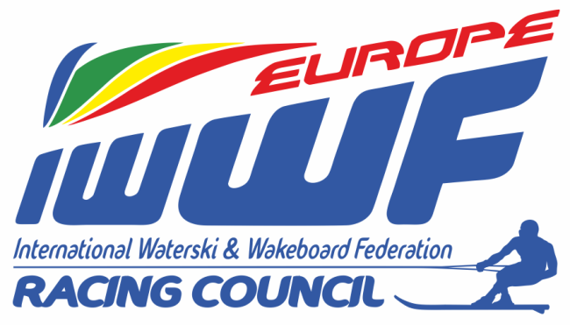

LIST OF THE E&A RACING COUNCIL MEMBERS FOR – 2018/2020

PRESIDENT :
Mr. Mike WATERMAN
E&A Admin Com Delegate
IWWF Racing Council Chairman
3, Alastair Drive, Yeovil, Somerset BA21 3BT, Great Britain
Tel: (H) +44 (0) 1935 478067 Fax: +44 (0) 1935 478067
GSM: +44 (0) 7747 672808
E-mail: michael.waterman@btconnect.com

SECRETARY-GENERAL :
Mrs. Vera VAN DEN BOSSCHE
IWWF Racing Council member
Blokkersdijkstraat, 2 – 2070 Zwijndrecht, Belgium
Tel: (H) +32 3252 83 79
GSM: +32 475 909 870
E-mail : vera.vdbossche@skynet.be

TREASURER :
Mr. Franz HEBENSTREIT
Donaugasse 10/2 – 3430 Tulln, Austria
Fax: +43 (0) 227261525
GSM: +43 (0) 664 8193084
E-mail : franz.hebenstreit@aon.at, franz.hebenstreit@abv.at

MEMBERS:

Mr. Jules LEYSEN (Technical and rules issues)
IWWF Racing Council member
Herentalse Steenweg, 78 – B 2270 Herenthout – Belgium
Tel.: +32 (0)14 501954
Fax: +32 (0)14 501952
GSM: +32 (0) 475 719465
E-mail: julius.leysen@skynet.be

Mrs. Thea KLARENBEEK (Boat numbers / Homologation)
IWWF Racing Council member - substitute
Voorsdorpsedijk, 9 - 3566 MN Utrecht – NL
Tel: +31 302 731019
GSM: +31 (0) 653 339309
E-mail: info@eurobetonboringen.nl

LIST OF THE E&A RACING COUNCIL MEMBERS FOR – 2018/2020

Mr. JONAS GARCIA HERNANDEZ (IT issues/Website/FB)
Calle Canales, 84-A-4, 38370 La Mantaza, Tenerife, Spain
Tel: (H) +34 922579141
GSM: +34 676472865
E-mail: jonasazules250@hotmail.com

Mr. Richard HERNAEZ (Promotion)
7 Rue du Général Bertrand
F - 36000 Châteauroux (France)
Tel: +332 54 34 47 84
GSM: +336 88 42 64 34
E-mail: richardhernaez@gmail.com

Mrs. Chris RYDL
Athletes Representative E&A Racing
J. Mattheessensstraat 56 – B2540 Hove – Belgium
Tel.: +32 (0)3 457 15 17
GSM: +32 (0)479458515
E-mail: c.rydl@skynet.be, chrisr@ecuanr.eculine.net

Issued 04/02/2018 valid for 2018/2020

Vera Van den Bossche
Secretary-General

